DEVELOPMENT OF A PORTABLE INCUBATOR FOR THE DETECTION OF COLIFORM IN WATER USING IOT

BY

OLONISAKIN DAVID AKOLADE

(18CK024244)

A PROJECT REPORT SUBMITTED TO THE DEPARTMENT OF ELECTRICAL & INFORMATION ENGINEERING, IN PARTIAL FULFILLMENT OF THE REQUIREMENTS FOR THE AWARD OF THE BACHELOR OF ENGINEERING DEGREE IN ELECTRICAL AND ELECTRONICS ENGINEERING.

 SUPERVISOR:

DR. OSEMWEGIE OMORUYI

JUNE 2023

# DECLARATION

I, OLONISAKIN DAVID AKOLADE (18CK024244), hereby declare that I carried out the work reported in this project in the Department of Electrical and Information Engineering, Covenant University, under the supervision of Dr. Osemwegie Omoruyi. I also solemnly declare that to the best of my knowledge; no part of this report has been submitted here or elsewhere in a previous application for the award of a degree. All sources of knowledge used have been duly acknowledged.

…………………………………………….

OLONISAKIN DAVID AKOLADE

18CK024244

# CERTIFICATION

This is to certify that the project titled “**DEVELOPMENT OF A PORTABLE INCUBATOR FOR THE DETECTION OF COLIFORM IN WATER USING IOT**” by OLONISAKIN DAVID AKOLADE, meets the requirements and regulations governing the award of the Bachelor of Engineering in Electrical and Electronics Engineering degree of Covenant University and is approved for its contribution to knowledge and literary presentation.

**Dr. Osemwegie Omoruyi**

(Supervisor) Sign: _________________ Date: ________________

**Internal Examiner** Sign: _________________ Date: ________________

**Dr. Isaac Samuel** Sign: _________________ Date: _______________

(Head of Department)

# DEDICATION

This research project is dedicated to my parents, Dr. Rotimi Olonisakin and Mrs. Bolatito Olonisakin who were very understanding and supportive throughout the time taken to complete this project, providing the resources necessary to make this project possible. I also dedicate this project to the countless communities in Nigeria who lack access to clean water.

# ACKNOWLEDGEMENTS

First and foremost, I would like to begin by expressing my deepest gratitude to God for His divine guidance, wisdom, and grace throughout this project. I am forever grateful for His constant presence and blessings in my life.

I would also like to extend my sincere appreciation to my parents for their unwavering love, support, and encouragement. Their sacrifices, guidance, and prayers have been a source of strength and motivation throughout this journey. I am truly blessed to have them as my role models.

I would like to express my heartfelt thanks to my project supervisor, Dr. Osemwegie Omoruyi for His invaluable guidance, expertise, and support. His insightful feedback, constructive criticism, and dedication have been instrumental in shaping the direction and success of this project.

Furthermore, I want to thank the Head of Department, Prof. Isaac Samuel, and all my lecturers for impacting me with knowledge and passing me through various tasks that have, in one way or the other, prepared me for the gallant execution of this project.

Finally, I would also like to acknowledge the support and encouragement of my lovely sisters, Favour and Delight Olonisakin, who have been there for me through thick and thin. Their kind words, motivational messages, and belief in my abilities have helped me to stay focused and motivated.

# ABSTRACT

Having access to clean and safe drinking water is considered a crucial human right, yet millions of individuals continue to live without it. The consumption of water that has been contaminated can increase the risk of experiencing outbreaks of different diseases that are transmitted through water, which are a leading cause of death worldwide. This project aims to develop a portable and low-cost incubator for detecting coliform bacteria in water, which is achieved by using a light-dependent resistor (LDR) and a heating element controlled by an IOT equipped microcontroller (ESP32). The incubator creates a controlled environment for water samples to incubate and for the LDR sensor to detect changes in turbidity, indicating the presence of coliform bacteria. Additionally, a Digital Humidity and Temperature (DHT22) sensor and a heating element helps maintain a temperature range of 35-37°C, the ideal temperature for optimal coliform bacteria growth. The incubator also features a Liquid Crystal Display (LCD) displaying resistance and temperature readings. After the data is collected, it is transferred to the microcontroller and subsequently transmitted to the Blynk application for continuous monitoring and analysis in real-time. The portability and affordability of this incubator makes it appropriate for use in remote areas where access to laboratory equipment is limited. The findings of this study carry significant implications for the advancement of low-cost and portable water quality monitoring systems, potentially leading to improvements in public health.

Keywords: ***portable incubator, water monitoring, coliform bacteria, light-dependent resistor***.

**TABLE OF CONTENT**

DECLARATION 2

CERTIFICATION 3

DEDICATION 4

ACKNOWLEDGEMENTS 5

ABSTRACT 6

LIST OF FIGURES 11

LIST OF TABLES 12

CHAPTER One 13

INTRODUCTION 13

1.1 Background of Study 13

1.2 Significance of Study 14

1.3 Problem Statement 15

1.4 Aim and Objectives 15

1.5 Methodology 16

1.5.1 Waterfall model of methodology 16

1.5.2 Description of the Waterfall model 17

1.6 Scope of Study 18

1.7 Limitations of the Study 18

1.8 Project Organization 19

CHAPTER Two 20

LITERATURE REVIEW 20

2.1 Introduction 20

2.2 Coliform Bacteria: A Quick Overview 20

2.3 Significant Factors that promote Coliform Bacteria infestation in water 23

2.3.1 Septic Tank Systems. 23

2.4 The significance of finding Coliform bacteria in water 28

2.5 Traditional methods of detecting Coliform in water 30

2.5.1 Membrane filter technique 30

2.5.2 Multiple-tube fermentation technique 31

2.5.3 Molecular methods 32

2.5.4 Enzymatic method/defined substrate method. 34

2.6 Internet of Things (IOT): A Quick Overview 34

2.6.1 Structure of the Internet of Things (IOT) 35

2.6.2 IOT's relevance for detecting bacteria in water and its utility in detecting coliform 37

2.7 Review of related works 38

CHAPTER Three 44

SYSTEM ANALYSIS AND DESIGN 44

3.1 Introduction 44

3.2 Components 44

3.2.1 ESP 32 44

3.2.2 Light Dependent Resistor (LDR) 45

3.2.3 Relay 45

3.2.4. DC-DC Converter 46

3.2.5 Electrical Heating Element 47

3.2.6 LED Bulb 47

3.2.7 Potentiometer 48

3.2.8 DHT22 Temperature and Humidity Sensor 48

3.2.9 Liquid Crystal Display (LCD) 49

3.2.10 I2C Serial Interface Adapter Module 49

3.2.11 Incubator 50

3.2.12 Beaker 51

3.2.13 Water Detect Coliform Powder 51

3.2.14 Power Supply Adapter 52

3.3 Design specification 53

3.3.1 Systems Block Diagram 53

3.3.2 Circuit Diagram 53

3.3.3 Systems Flowchart 54

3.3.4 Electrical Calculations 54

3.4 Description of Software Requirements 58

3.4.1 Arduino Integrated Development Environment (IDE) 58

3.4.2 Blynk 59

3.5 Conclusion 60

REFERENCES 61

# LIST OF FIGURES

Figure 1.1: Waterfall model 16

Figure 2.1: Different Groups of Coliform Bacteria [7] 22

Figure 2.2: IoT Analytics Flow [60] 37

Figure 3.1: Expressif Systems Processor (ESP) 32 45

Figure 3.2: Light Dependent Resistor (LDR) 45

Figure 3.3: Relay 46

Figure 3.4: DC-DC Buck Converter 46

Figure 3.5: Heating Source 47

Figure 3.6: LED Bulb 47

Figure 3.7: Potentiometer 48

Figure 3.8: DHT 22 48

Figure 3.9: Liquid Crystal Display 49

Figure 3.10: I2C Serial Interface Adapter Module 50

Figure 3.11: Incubator 50

Figure 3.12: Beaker 51

Figure 3.13: Water Detect Coliform Powder 52

Figure 3.14: Power Supply Adapter 52

Figure 3.15: Systems Block Diagram 53

Figure 3.16: Circuit Diagram 53

Figure 3.17: Systems Flowchart 54

Figure 3.18: Arduino Integrated Development Environment (IDE) 58

Figure 3.19: Arduino Integrated Development Environment (IDE) Code Snippet 59

Figure 3.20: Blynk Application 60

# LIST OF TABLES

# 

INTRODUCTION

## 1.1 Background of Study

The study was inspired by the need for precise and trustworthy techniques for identifying waterborne infections, especially coliform bacteria, in places with few laboratory facilities. Coliform bacteria are used as a quality gauge for water and are a sign that potentially dangerous diseases may be present. The provision of drinking water is one of the major public health objectives because it is intimately related to human health. Consuming water that contains hazardous chemicals or pathogenic organisms has a major influence on one's health[1].

The lack of low-cost, simple-to-use, and accurate techniques for remote water monitoring and coliform detection is the key issue driving this research. Due to difficulties with transportation, sample storage, and inadequate laboratory facilities, traditional laboratory-based approaches are frequently not practical in remote places. Thus, the creation of a mobile incubator for coliform detection could be the answer to this issue.

The goal of 0074his project is to develop a portable incubator that can quickly and accurately detect coliform bacteria in water using an approach that is both affordable and simple to use. Detection of these organisms consists of, for example, filtering a 100 mL water sample through a membrane followed by incubation of the membrane on selective media at 35 - 37 °C (E. coli) or 44 - 45 °C (TTC) [2] . The issue of restricted access to laboratory facilities for water monitoring and coliform detection can be resolved by the portable incubator, especially in distant locations. The study is important because it may increase access to clean water, especially in locations where waterborne diseases are common. The mobile incubator might also be used for environmental research and monitoring, which would improve water management and public health.

## 1.2 Significance of Study

The development of a portable incubator for remote water monitoring and detection of coliform is an important initiative that can improve access to safe water, particularly in remote areas. Traditional laboratory-based methods for coliform detection are often not feasible in such areas due to transportation, sample storage, and limited laboratory facilities.

This project aims to address the problem of limited access to laboratory facilities by providing a low-cost, easy-to-use, and reliable method for remote water monitoring and coliform detection. The portable incubator is designed to use an LDR and a bulb, where a resistance drop or increase is detected depending on the coliform growth. This data is then sent to the ESP32 for further analysis. Additionally, a DHT 22 sensor is in place to regulate the temperature of the incubator at 35-37 degrees Celsius via the heater. The significance of this study is highlighted below;

1. Improve access to safe water, particularly in remote areas.
2. Enhance public health efforts in identifying and preventing waterborne diseases.
3. Contribute to water management and environmental monitoring research.
4. Increase efficiency in water monitoring by eliminating the need to transport water samples to a laboratory for analysis.
5. Enable citizen science initiatives for community-led efforts towards sustainable water management.

## 1.3 Problem Statement

The current methods for detecting coliform bacteria in water samples require laboratory analysis, which can be time-consuming and resource-intensive. This can limit the ability to effectively monitor water quality, particularly in remote areas. Therefore, there is a need for a portable incubator that can detect coliform bacteria remotely, and enable more efficient and timely water monitoring activities.

## 1.4 Aim and Objectives

**Aim**: To develop a portable incubator for remote water monitoring and detection of coliform.

**Objectives**

The objectives of this project are:

1. To design and construct a portable incubator that maintains a temperature range of 35-37°C using a ESP32-powered relay to control the heating element and sensor readings.
2. To detect coliform bacteria growth using an LDR sensor and a bulb by monitoring the changes in resistance.
3. To develop a real-time monitoring and data visualization of coliform levels.
4. To validate the accuracy and effectiveness of the portable incubator in detecting coliform bacteria.

## 1.5 Methodology

The proposed research falls under the field of environmental science and aims to analyze the quality of water samples collected from various sources around Covenant University. The project will utilize the Waterfall model of methodology, an iterative process for creating a system or solving a problem that structures the entire job into segments to ensure precision.

### 1.5.1 Waterfall model of methodology

This project has been completed by following strategy, which is given in Figure 1.1

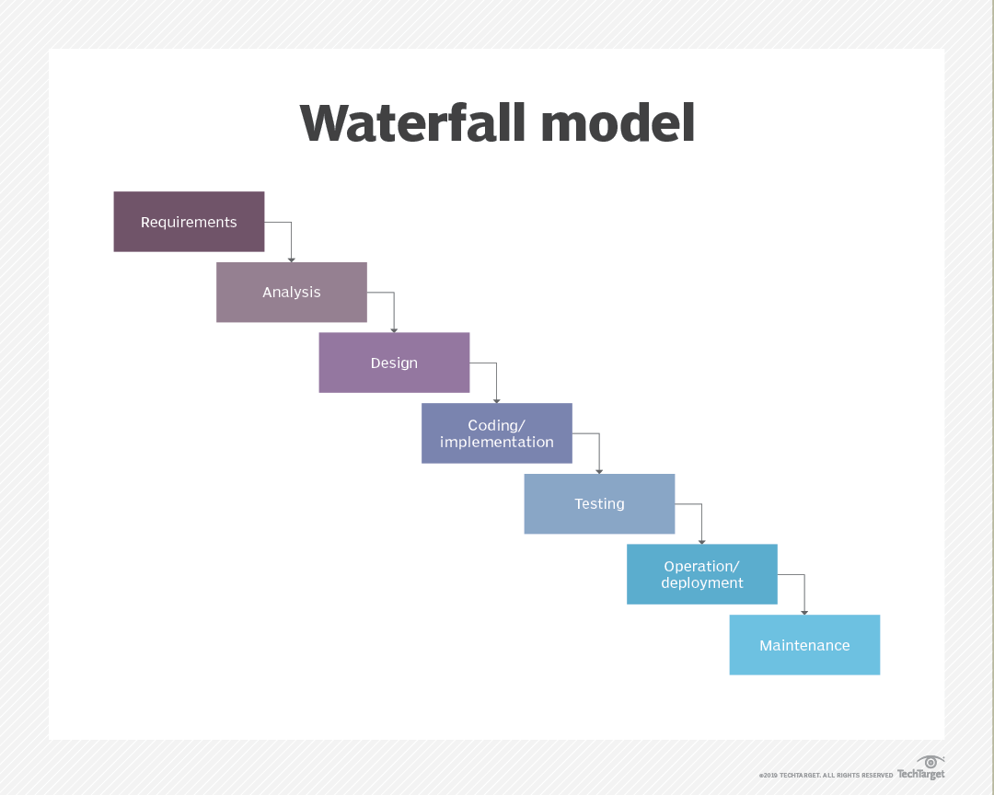

Figure .: Waterfall model

### 1.5.2 Description of the Waterfall model

The work has been grouped into seven sections;

1. **Requirements Gathering Phase**: In this phase, the aim and objectives of the project will be defined, and the specific requirements for the research will be gathered.
2. **Analysis Phase**: In this phase, the water sources around Covenant University will be analyzed, and the most suitable water samples for the experiment will be identified and selected based on specific criteria.
3. **Design Phase**: In this phase, the portable incubator will be designed, and the DHT22 sensor and LDR will be integrated into the system.
4. **Implementation Phase**: In this phase, the incubator will be set up, and the selected water samples will be placed in it. The temperature and light exposure within the incubator will be monitored using the DHT22 sensor and LDR, respectively.
5. **Testing Phase**: In this phase, any changes in the resistance levels of the LDR due to bacterial growth in the water samples will be recorded.
6. **Deployment Phase**: In this phase, the data collected during the testing phase will be analyzed using statistical methods to determine the presence and concentration of coliform bacteria in the water samples.
7. **Maintenance Phase**: In this phase, any necessary adjustments to the experiment will be made based on the findings of the study. Finally, conclusions and recommendations will be drawn based on the results obtained.

## 1.6 Scope of Study

The scope of this study is to design and develop a low-cost and portable incubator for remote water monitoring and detection of coliform bacteria. The incubator will utilize a light-dependent resistor (LDR) to detect changes in turbidity, and a DHT22 sensor to maintain a constant temperature of 35-37°C within the incubator. The incubator will be powered by 230 AC – 5V DC power adapter and monitored using ESP32 module. The study will involve designing and constructing the incubator, testing its sensitivity and specificity for detecting turbidity increases, and evaluating its performance in a real-world setting. The study aims to provide a low-cost and effective solution for monitoring water quality in remote areas where access to laboratory equipment is limited.

## 1.7 Limitations of the Study

Limitations associated with this project include:

1. The accuracy of the coliform detection may be affected by factors such as the quality of the water sample or the calibration of the LDR sensor.
2. The use of an ESP32 microcontroller for data transmission may have limited range and reliability in remote areas with poor internet connectivity.
3. The incubator may require frequent calibration and maintenance to ensure consistent temperature and humidity levels for accurate readings.
4. The heating source required to increase the temperature in the incubator uses up a significant amount of power, which makes it impractical to use a battery as a power source.
5. The size and portability of the incubator may limit the amount of water samples that can be tested at once, potentially affecting the scalability of the system.

## 1.8 Project Organization

**Chapter One**: It provides a general overview of the project, background

information, the project's goal and objectives, the issues it aims to address, and a

brief description of the approach.

**Chapter Two**: Provides a review of the literature and investigates past relevant

studies on the project's issue. It gives a theoretical framework as well as other ideas

necessary for a complete grasp of the project.

**Chapter Three:** It discusses the project's methodology, the various components

required with specifications, and the project's design, as well as all of the

components required for innovation, system block diagram representation, and

hardware design.

**Chapter Four:** It covers the implementation and testing of the project. The project's

practical system design and in-progress photos will be shown. The results of the

project will be discussed.

**Chapter Five:** The last chapter. It contains the study's conclusions and outcomes. It also displays the project's achievements.

# 

LITERATURE REVIEW

## 2.1 Introduction

Many researchers have investigated the prevalence of coliform bacteria in various water sources. The existence of coliform bacteria in drinking water is a major public health concern. Although total coliform bacteria are widespread and typically not harmful, the presence of fecal coliforms and E. coli may pose a potential danger to human health. Coliform bacteria are commonly used as water quality indicators and are divided into three categories: total coliforms, fecal coliforms, and E. coli[3] . This chapter provides a comprehensive overview of Coliform bacteria, including the major factors that contribute to their presence in water, the potential health effects of exposure to these bacteria, traditional methods for detecting them in water, relevance of IoT technology in the detection of Coliform bacteria in water and review similar works in the literature.

## 2.2 Coliform Bacteria: A Quick Overview

Coliform bacteria are rod-shaped, non-spore-forming, Gram-negative, oxidase-negative, facultatively anaerobic organisms that have a cell wall appearing pink or red when stained and can survive in both oxygenated and non-oxygenated environments [4]. Coliforms are a type of bacteria that can be found in the digestive systems of animals, including humans, as well as in soil and plants. While generally not harmful, the presence of specific types of coliforms, such as E. coli, in drinking water can indicate that the water may be contaminated with feces, which can pose a risk of infection. If E. coli is found in the water, there is a possibility that other pathogens may also be present, since E. coli itself can be a pathogen. The intestine of warm-blooded mammals is where it typically began [5]. In the past, the presence of the intestinal bacteria known as coliforms has been cited as a sign that a location has been contaminated by sewage from people. Additionally, the feces of affected people contain harmful germs including Shigella and Salmonella[6].

Coliform bacteria are classified into three types that indicate the safety of water and differ in the level of risk. The term "total coliform" encompasses a wide range of bacteria, including those present in fecal matter, which is a subset of all coliforms. E. coli is a type of fecal coliform bacteria. When testing drinking water samples, laboratories check for the presence of total coliform, and if it is detected, the sample is further examined for the presence of E. coli[3] . The presence of total coliform bacteria is commonly observed in nature and does not pose a significant threat. When only total coliform bacteria are detected in drinking water, it suggests that the contamination source is likely environmental [7].

**Total Coliform Bacteria:** The total coliform bacteria, which are common in the ecosystem and are most commonly found in dirt or plants, are usually safe. If a lab only finds total coliform bacteria in drinking water research, it is likely that the bacteria came from the environment and fecal pollution is rare. However, there is a chance that harmful germs could get inside the system if it is prone to external pollution. As a result, it is vital to find and resolve the contamination's main cause.

**Fecal Coliform Bacteria:** Fecal coliform bacteria, which are a subgroup of total coliform bacteria, are abundantly found in the intestines and feces of both humans and animals. The identification of fecal coliforms in a water sample is typically indicative of recent fecal contamination, and this poses a higher risk of potential pathogen presence compared to situations where only total coliform bacteria are identified[7].Top of Form

**Escherichia coli:** The bulk of E. coli types usually pose little worry and typically live in the guts of humans and warm-blooded animals. E. coli is classed as a subset of fecal coliform germs. However, some kinds of E. coli can make people ill. When E. coli bacteria are found in a potable water sample, it usually means that there has been recent fecal pollution, which boosts the chance that disease-causing germs are present [7]The identification of Escherichia coli in water samples typically indicates fecal matter contamination, along with the potential presence of pathogenic organisms of human origin[7]. Since E. coli can also be a pathogen, there is a possibility that other pathogens will also be present if E. coli is discovered in the water[5]. Escherichia coli bacteria were typically found in sewage discharges from human, animal, and plant sources, in that order. Septic system failure, municipal landfills, and wastewater sludge application to the land are all examples of human sources. Fecal coliform

bacteria also enter from a variety of animal sources, including domestic pets, wildlife, livestock, land application of manure, pasture areas and feedlots[8].

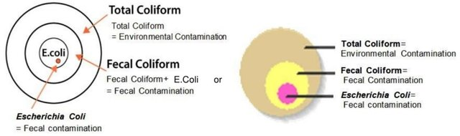

Figure .: Different Groups of Coliform Bacteria [7]

## 2.3 Significant Factors that promote Coliform Bacteria infestation in water

Water sources containing coliform bacteria pose a significant risk to the public's health and are frequently contaminated by feces due to improper sanitation practices or agricultural activities. It has been claimed that septic tank systems and farm waste are the main contributors to coliform bacteria in drinking water. Septic tank overflow and other related factors contaminating drinking water sources with human feces particularly raise the risk of Coliform contamination. The risk of contracting a waterborne disease can also be increased by the use of pesticides and fertilizers in agriculture, which can reduce the spread of coliform bacteria to water sources. Finding and monitoring coliform bacteria in drinking water is essential for maintaining public health and halting the spread of infectious illnesses.

### 2.3.1 Septic Tank Systems.

One of the most significant issues facing the world today is water contamination. Septic tank effluent intrusion is one of the main sources of groundwater contamination. The main source of harmful viruses and bacteria in the subterranean environment may be septic tank effluent[9]. Contamination of aquifers has become a common problem as a result of excessive groundwater pumping and uncontrolled human wastewater dumping into the groundwater. Groundwater quality can be impacted by residential, business, industrial, and agricultural activities. Groundwater is particularly sensitive in regions with large population densities and extensive human use of the land[10]. Waste is temporarily stored in a septic tank while being pre-treated at that time. There have been reports of septic tanks failing and leaking a lot, harming the ecosystem[11]. Studies have been conducted by various researchers to demonstrate the negative impacts of situating septic tank systems close to drinking water sources. An investigation into groundwater contamination in the Agbowo neighborhood of Ibadan, Nigeria, as well as the effects of septic tank distances from wells was conducted[12]. Septic tanks have been found to fail and leak profusely, causing environmental damage[11] As a result, septic tanks are the primary source of waste that is directly released into groundwater. So, in order to safeguard both the environment and human health, it is essential to monitor water[13]. Replicas of forty (40) ground water samples were collected from groundwater sources at different distances for bacteriological analysis, and it was found that they were all infected with different types of bacteria as well as coliform[12]. The number of feces and total coliforms decreased with increasing distance from septic tanks, and this effect was more pronounced for water supply distance from pollution sources. Because the problem of septic tank contamination of ground water is a national concern rather than a local one in the study region, measures should be taken by developing standards for the isolation of wells from septic tanks and the treatment of well water before use[12]. Consuming groundwater that has been faecally contaminated and not properly treated has been related to disease[14].

Underground water, or the water found below the earth's surface in soil pores and rock formation fractures, has been impacted by the deterioration of the physicochemical and biological qualities of water brought on by industrialization and urbanization, which have grown over time without consideration for the effects on the environment[15]. As a result of population expansion and urbanization, ground and surface water are subject to greater demands. The startling rate of urbanization in Nigeria is reflected in the 10–15% yearly growth rates of the country's main cities[16] hence human activities like enhancing soil fertility, irresponsibly disposing waste, and utilizing pit latrines, soak-away pits, and septic tanks are increasing. In Nigeria, it is challenging to find pipe-borne water, thus many homes have wells that are close by but separate from the septic tank. Only 52% of Nigerians have access to adequate drinking water sources[17]. The most common causes of pollution include the close proximity of septic tanks to wells, the unhygienic use of the wells (for example, some wells have no covers or lids; they are dirty and unkempt, making the water unfit for use, resulting in water-borne diseases), and the unhygienic use of the wells. Additionally, the discharge of solid or liquid waste into pits, abandoned boreholes, stream channels, landfills, or other unlined sites may result in groundwater contamination[18].

The authors of a different study investigated the origins of E. coli contamination in the coastal subtropical climate. They found that septic systems were a substantial source of E. coli and total coliforms in both surface water and sediment. It was evident that septic systems were a substantial source of pollution since there was a positive correlation between the amount of E. coli in sediment and the distance from them. The authors asserted that septic systems are a significant source of fecal contamination in coastal areas and suggested introducing measures to guard against contamination from septic systems[19]. Another study looked at how the presence of septic tanks affects the quality of the borehole water in Port Harcourt, Nigeria[20]. In order to reach their conclusions, the researchers collected water samples from boreholes both close to and distant from septic tanks. Total dissolved solids (TDS), pH, total suspended solids (TSS), and bacterial contamination were all investigated in the water samples (TSS). The researchers found that the water quality in boreholes near sewage tanks was significantly lower than in boreholes farther away from septic tanks. The water samples collected from the vicinity of septic tanks contained higher concentrations of TDS, TSS, and bacterial contamination, including coliform bacteria[20].

Another study used one-way ANOVA (Analysis of Variance) to examine the relationship between fecal coliform contamination and proximity to the septic tank. The results showed that fecal coliform was present in 96 percent of the sampled wells, indicating that the drilled well's biological drinking water quality had been significantly diminished. The excavated well was 53.7 feet away on average from the septic tank. The results of the investigation showed that as the distance between the septic tank and the drilled well rose, the level of fecal coliform contamination dropped. There were strong evidence of fecal pollution in the dug-well water at 50% of the septic tanks within 50 feet[21].

1. **Septic tank setback distances from water sources**

Since the distance between septic tanks and water sources plays a significant role in the coliform bacteria that cause water to become contaminated, various approaches for estimating setback distances and conditional probabilities have been examined. In the past, the majority of governmental organizations enforced minimum setback distances between septic tanks and drinking-water wells to restrict where septic tanks may be located[22]. How likely is it that a setback distance (such one required by the regulatory body) will be adequate to protect the city's ground water from virus contamination? Given a specific probability level, what setback distance would be necessary to ensure that the ground water would be immune to virus contamination?[23] With little respect for the local geology, hydrology, and meteorology, these setback distances are often required for at least a county-wide area[23]. Various places have different topologies. Therefore, proper setback distance calculations must be made by regulatory agencies in order to ensure that the distance of septic tanks from water sources would give complete assurance that the water is not contaminated with coliform. A study revealed that a setback distance of 40 m would be required for a specific location under consideration in order to be 90% confident that the ground water would be appropriately protected from virus contamination. If one wanted to be 99% sure that the setback was enough to stop viral transmission in places where 15-m distances were first permitted, an 80-m distance would be required[23].

1. **Inadequate agriculture practices**

Numerous studies have demonstrated how agricultural pollution may significantly contribute to the coliform water contamination. One of the main sources of contamination is the over use of fertilizers, notably those containing nitrogen and phosphorus. According to the National Geographic Society, nutrient contamination brought on by excessive fertilizer use leads to eutrophication, a process that harms both terrestrial and aquatic ecosystems by overburdening them with nutrients[24]. Coliform water contamination is a global problem that threatens the health of both people and animals. Ineffective agricultural techniques have been identified as one of the main sources of this problem. For instance, it is common knowledge that increasing soil fertility with animal manure also increases the quantity of fecal coliform bacteria in the water. Therefore, excessive levels of fecal coliform bacteria and other pathogens can contaminate surface and groundwater when animal dung is improperly handled or applied[25]. Surface water, such as streams and rivers, can be contaminated by runoff from feedlots and farms, and groundwater can be affected by pollutants that seep through the soil layers. People and animals may be exposed to toxins while using contaminated groundwater for irrigation or drinking. Various management strategies can be applied to lessen the quantity of water pollution brought on by agricultural activities. Among these include reduced use of pesticides and fertilizers, conservation tillage, nutrient management programs, and manure management strategies. Additionally, by creating buffer strips or wetlands or increasing irrigation effectiveness, runoff can be reduced and contaminants in surface water can be filtered[26]. Water sources may be impacted by pesticides, herbicides, and fungicides used in agriculture. It is well recognized that these agricultural contaminants deteriorate groundwater and surface water quality[27]. Using contaminated irrigation water and disposing of animal corpses inappropriately are two other poor farming techniques that could cause coliform contamination[28]. Rainfall and flooding are other causes of water contamination. They accomplish this by introducing potentially harmful chemicals and contaminants into water sources from a variety of sources. Studies conducted in the lab and in the field indicate that there are significant numbers of bacteria in water, which are primarily brought on by frequent tidal floods and strong rain events[29]. Inadequate water consumption spurred on by population increase, urban wastewater runoff, hospital waste, and institutional waste are other causes of coliform contamination of water[21].

Poor hygiene habits, such as defecating outside, and poorly maintained wells that have free access make them more susceptible to anthropogenic pollutants[30]

## 2.4 The significance of finding Coliform bacteria in water

Monitoring is the primary line of defense against diseases brought on by dangerous microbes. Effective detection methods are needed in order to control this effect[31].

For the purpose of detecting the presence of contaminants in water, accurate and quick reaction detection technologies are required[32]. Water safety and cleanliness are basic human rights and needs for all living beings[33]. The three most basic uses of water—drinking, food preparation, and personal hygiene—require each person to use at least 7.5 liters of water per day in the home. At least 50 liters of water per person per day are necessary for all requirements related to personal cleanliness, food hygiene, housekeeping, and laundry[34]. However, due to its importance as a way of propagating pathogenic organisms, man is now worried and terrified of it[35]. Animal and human waste is a significant contributor to water pollution, which is extremely hazardous to the health of millions of people worldwide. Waterborne illnesses like cholera, polio, diarrhea, hepatitis, typhoid, dysentery, and gastroenteritis are brought on by these microorganisms that contaminate the water supply[36]–[38]. One of the top 15 global killers is diarrheal disease[39]. More children die from diarrhea than from tuberculosis and malaria combined[34]. Millions of people globally are afflicted by other ailments linked to WASH. Over 800,000 deaths are attributed to inadequate WASH each year, particularly among children under five[40]. Elderly and young people often suffer more from the harmful health effects of drinking water contaminated with E. coli[41]. One of the greatest challenges to advocating for and implementing safe water initiatives is the difficulty of measuring and assessing the microbiological features of water in rural developing communities. Many remote settlements lack the equipment and knowledge necessary to assess the microbiological purity of the water before use. Despite the large number of hazardous microbes, testing for all of them is challenging[42]. In order to reduce the reliance on laboratory testing and avoid the difficulty, expense, and delays associated with sending samples offsite for testing, particularly in situations where the closest laboratory is far away or doesn't have a reliable electricity supply, there is a high desire for simpler, quicker, and less expensive procedures that will allow for more regular testing of water for communities or individual households[43].

## 2.5 Traditional methods of detecting Coliform in water

Drinking water is an oligotrophic system, thus the inability of culture methods to recognize starved and stressed bacterial cells could have serious repercussions by drastically underestimating contamination levels. There are other alternative methods for recognizing coliforms, albeit they are all at different stages of development and implementation. In this overview, cutting-edge and new methodologies are discussed alongside the fundamental principles and accepted practices of traditional methods of Coliform detection. Additionally, based on each method's benefits and drawbacks, the efficacy of finding coliforms in oligotrophic environments, such drinking water, is assessed. Additionally, criteria like detection sensitivity and limit, amount of time needed to collect data, and laboratory costs are taken into account (including skill, labor, and cost)[4].

Traditional methods include membrane filter technique, multiple-tube fermentation technique, enzymatic/defined substrate method and molecular methods.

### 2.5.1 Membrane filter technique

One method for estimating the number of microorganisms in drinking water is the membrane filter technique, which has achieved acceptance in a number of countries. Membrane filter technology is used to keep an eye on water quality. This method comprises running a water sample through a 0.45 mm-pore filter that is sterile and bacteria-retentive. After the filter has been cultivated on a selective medium, the typical colonies on the filter are then counted. Different media and incubation conditions were investigated in order to determine the best procedure for recovering coliforms from water samples. In North America and Europe, respectively, the m-Endo-type media and Tergitol-TTC medium are widely used for drinking water analysis[44]. Coliform bacteria produce yellow-orange colonies on Tergitol-TTC media after 24 to 48 hours of incubation, whereas they produce red colonies with a metallic sheen on an Endo-type medium containing lactose. Although research suggests that m-Endo agar is more effective at producing higher numbers of coliforms, other media, such as MacConkey agar and Teepol medium, have been used in South Africa and the United Kingdom. To determine the number of fecal coliforms present, filters are frequently cultivated for 24 hours at 44.5°C on an improved lactose medium (m-FC)[44].

### 2.5.2 Multiple-tube fermentation technique

Over the past 80 years, the multiple-tube fermentation (MTF) approach has become a popular methodology for enumerating coliforms and monitoring water quality. As part of the technique, a number of tubes with different decimal dilutions of the water sample are introduced. When there is gas generation, acid formation, or significant growth in the test tubes after 48 hours at 35°C, this is a positive presumptive reaction. Lauryl tryptose broths and lactose broths can both be used as presumptive media. Confirmation tests are run on all tubes following the observation of a positive presumptive result. A brilliant green fermentation tube of lactose-bile broth must produce gas within 48 hours at 35°C to pass a confirmation test[4].

The outcomes of the MTF method are expressed using the most probable number (MPN), which is a statistical estimation of the mean number of coliforms. Using this technique, it is possible to determine the coliforms semi-quantitatively. The measurement's level of precision is poor because few tubes were used for the analysis. The likelihood of getting a negative result when using five tubes, each with a volume of 1 ml of the material, is less than 1%.

Despite its limitations, the MTF technique is still widely used and a good way to check water quality. Some of its benefits include simplicity and low expense. However, compared to the defined substrate approach, this technique has a significant disadvantage due to its lengthy incubation period. The MTF technique is a vital instrument for ensuring the safety of drinking water because it can identify both total and fecal coliforms. However, the MTF technique's lack of accuracy, brought on by its reliance on statistical estimates, raises the possibility that it may not be the best technique in circumstances where high precision is required. Alternative approaches with higher accuracy, like PCR-based techniques, may be preferred in such cases.[4]

### 2.5.3 Molecular methods

There are now a variety of molecular methods that can quickly, sensitively, and accurately identify infectious pathogens in clinical samples and assess the microbiological safety of food and water. These methods have been developed over the past 20 years. Without separating or growing the microorganism, these procedures can frequently offer qualitative and quantitative information about the existence and quantity of the targeted microbe in the samples. These methods can also be changed in order to identify a specific pathogenic trait carried by the microorganism. A vast variety of target molecules can be found, with each technique's goal being to give knowledge for the prevention of infectious diseases[45]. The following are the molecular techniques used to find coliforms in drinking water

1. **Polymerase chain reaction method**

Researchers can swiftly amplify a very little DNA sample (or a portion of it) to a big enough quantity to investigate in detail using the polymerase chain reaction (PCR), which is a technique that is routinely used to produce millions to billions of copies (full or partial) of a given DNA sample[46]. An amplified DNA target segment can now cycle through replication thanks to this reaction. A DNA polymerase (Taq polymerase) catalyzes a chain reaction, and oligonucleotidic primers are utilized in this replication, which can be done in vitro or in situ. The sensitivity of the detection depends on the degree of homology and complementarity between the target and primer as well as the hybridization temperature[44]. The ability to identify coliform bacteria was investigated using gene probe detection and polymerase chain reaction (PCR) amplification of portions of two genes, lacZ and lamB. Salmonella spp. and noncoliform bacteria were not discovered when a section of the lacZ coding area of Escherichia coli was amplified using PCR primers with an annealing temperature of 50 degrees C. However, the procedure did detect E. coli and other coliform bacteria, including Shigella spp. Salmonella, Shigella, and E. coli spp. were all discovered using the selective detection of E. coli by amplification of a section of E. coli lamB using a primer annealing temperature of 50 degrees C[47].

1. **Nucleic Acids**

Nucleic acid polymers, such as DNA and RNA, are good molecular targets for identifying species and identifying specific phylogenetic sources. Numerous molecular techniques for coliform detection have been developed thanks to the stable genotype properties of nucleic acids[45]. Coliforms in drinking water must be found in order to protect public health, and nucleic acid-based molecular techniques have proven to be a quick, sensitive, and reliable way to do so[44]. Overall, nucleic acid-based molecular approaches provide a number of advantages over traditional culturing methods for the identification of coliforms in drinking water. They don't require labor- or time-intensive culturing methods and can identify coliforms rapidly and precisely. These techniques are essential because they reliably identify the presence and amount of coliforms in water samples, protecting public health, and preventing the spread of infectious diseases [44].

### 2.5.4 Enzymatic method/defined substrate method.

The Colilert-18 is one of the most often used defined substrates for the enzymatic test because it contains the nutritional indicators ONPG and MUG from Defined Substrate Technology (DST), which confirm the presence of E. coli and Coliform bacteria. The US EPA has authorized the reagent as a routine procedure for evaluating treated and tainted water since it may deliver results in just 18 hours. With the use of this reagent, you may attain 100% test accuracy. Colilert-18 reagent will be entirely soluble in water after being shaken into water samples[48]. Other efficient substrates, such those created by the Italian business Liofilchem, are already on the market and are suitable for the detection of coliform in water. Samples are incubated for 18–24 hours at 37°C or for up to 48 hours at room temperature (20–25°C)[49]. Coliforms have the enzyme β-galactosidase, which they use to create gases and acids when the temperature is between 35 and 37 °C, which is ideal for growth[50]. A certain enzyme will produce color or fluorescence when it digests a chromogenic or fluorogenic substrate. These substrates have been used to determine whether or not certain enzymes are present or active in water. In order to identify the presence of b-D-glucuronidase in E. coli, researchers utilized the chromogenic substrate indoxyl-b-D-glucuronide (IBDG). Several commercial tests based on this defined substrate technology were subsequently developed, including Colilert (IDEXX Laboratories, Portland, ME, USA), Colisure (Millipore Corporation, Bedford, MA, USA), and Coli-Quick (IDEXX Laboratories, Portland, ME, USA) (Hach, Loveland, CO, USA)[4].

## 2.6 Internet of Things (IOT): A Quick Overview

The term "Internet of Things" (IoT) refers to a network of actual physical items that have been integrated with sensors, software, and other technologies and are able to communicate with other devices and systems over the internet without the need for manual input. These gadgets include anything from common domestic items to high-tech industrial gear[51]. These objects have the ability to perceive, communicate, interact, and function together without requiring human-to-human or human-to-computer interaction thanks to integrated technology and a network of physical objects[52]. The Internet of Things (IoT) is about more than just connected devices; it's also about the data those devices gather and the immediate, potent insights that can be drawn from it [53]. Internet of Things (IOT) increases productivity since it reduces reliance on humans[54]. This program has been used to develop programs for monitoring ranging from surveillance, healthcare, and the environment all around the world[55].

### 2.6.1 Structure of the Internet of Things (IOT)

Sensors, microcontrollers, and application platforms make up the IOT architecture.

1. **Sensors**

IoT sensors track environmental changes in real time by detecting the physical environment[56]. The major objectives of IoT sensor networks include (i) receiving important information from the outside physical world, (ii) sampling internal system signals, and (iii) using sensor data to offer relevant information for decision-making[56], [57]. These sensors have nodes built in that are linked to microcontrollers that are in charge of reading and analyzing the data collected by the sensors. Temperature, pressure, humidity, level, accelerometer, gas, gyroscopes, motion sensors, image, optical, RFID, and infrared (IR) sensors are the most often utilized IoT sensors[56]. The small size of the sensor causes technical restrictions in areas like computational power, battery life, networking ability, storage capacity, and memory, despite the fact that sensors have a wide range of applications. This means that these sensors could be very vulnerable to errors, assaults, and simple failure, which could lead to the loss of sensor data and erroneous information[56].

1. **Microcontroller**

A microcontroller is a small computer with network access and program execution capabilities. The controller manages the collection of numerical data from the sensors, which it can then upload to the cloud or the internet for storage and analysis[58], [59]. Minicomputer- and microcontroller-board-based IoT controllers can be distinguished from one another. Microcontrollers like Arduino are more affordable than minicomputers and can run the same program repeatedly. The ESP is an additional instance of a microcontroller (ESP32, ESP8266). As an alternative, portable, full-featured computing devices that are capable of handling a variety of tasks include minicomputer-type controllers like the Raspberry Pi. While an Arduino board requires additional external hardware in order to connect to the internet, the Raspberry Pi comes with an Ethernet and Wi-Fi network interface built in[59].

1. **Application Platform**

Without applications, the Internet of Things is meaningless. Applications for the Internet of Things provide reliable communication and real-time message transmission. An application is essentially a piece of software that runs online and, after receiving input from a microcontroller, displays data via a user interface. Some platforms, like Blynk, provide apps for managing and monitoring IoT devices using mobile devices. FreeBoard, Ubidots, and ThingSpeak are three other popular platforms for IoT applications[59].

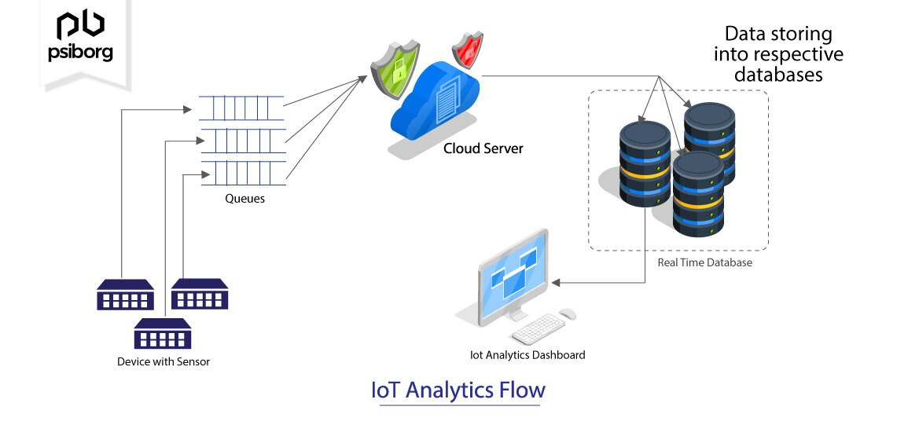

Figure .: IoT Analytics Flow [60]

### 2.6.2 IOT's relevance for detecting bacteria in water and its utility in detecting coliform

Water samples and the data that go with them are often processed and examined in laboratories. This may take a lot of time and effort and result in less trustworthy results. In light of the situation, it is essential to establish a suitable and organized system to continuously monitor and manage water resources in order to address connected challenges. Thanks to the Internet of Things (IoT), real-time remote measurements may be conducted with little to no human participation, providing a great alternative to conventional, complicated, and unsuccessful techniques for reaching this goal[61]. Due to the harmful health implications of consuming contaminated water, real-time water quality monitoring is now required. The Internet of Things (IoT) domain addresses this problem by providing creative and reasonably priced solutions for the problems of water contamination detection and water quality analysis[62].

The following are some benefits of using IOT for water quality monitoring:

1. **Decreased cost of computing**: The considerable amount of computing work, like that required by the Ubidots IoT-Platform, is handled by cloud servers. With the passage of this law, any widely used processor-based node (such as the NodeMCU (ESP32) kit) may be used in place of sophisticated microprocessors like the Raspberry Pi 4 Model-B, DE1 SoC FPGA board, etc [63].
2. **Hardly any human involvement:** IOT systems can increase efficiency by reducing reliance on humans[64].
3. **Low cost:** IoT solutions are generally more cost-effective than traditional water monitoring techniques since they make use of currently in use, commercially available communication infrastructure, which is also more time-consuming[63].
4. **Low power requirements:** The local nodes only need to carry out minimal work after shifting the majority of the computing workload to the cloud server, and they can then primarily sleep. This made it possible to operate sensor nodes in far-off places with a little battery.
5. **Real-time feedback delivery:** The proper water authority and end users can both immediately receive real-time input from these systems via SMS, email, Twitter, Facebook, and other means[63].

## 2.7 Review of related works

This section analyzes experiments that involved the development of an improvised incubator for coliform growth in contaminated water samples as well as the identification of coliform and other types of bacteria in water using Internet of Things (IoT) technology. The next paragraphs concentrate on a few of the numerous research studies that have been carried out in this field.

A sensor-based Water Quality Monitoring System was employed in another study[52] to measure the water's molecular and physical properties, including its pH, temperature, turbidity, and Total Dissolved Solids. (TDS). The authors' IoT-based solution consisted of three main components: a multiparameter water quality analyzer, a means for information transmission, and a computer system unit. Sensors, Wi-Fi wireless transmission, an STM32 single chip microcontroller, and remote water quality monitoring were all included in the proposed system. The data on water quality collected were evaluated using ANOVA-based statistical analysis to identify the key causes of the river Krishna's deteriorating water quality. In order to identify the primary causes of water pollution, the writers gathered and examined real-time data on the river Krishna's water quality using IoT-based water quality monitoring.

An Internet of Things (IoT)-based technique for predicting bacterial contamination in water was proposed by the authors of a study paper[61]. The system places a variety of instruments around the study area, including those that track dissolved oxygen, turbidity, pH level, water temperature, and total dissolved solids, to evaluate the water quality. These sensors transmit the data they have collected to a server using GSM modules, where it is processed and examined. The scientists used machine learning methods to predict the presence of coliform bacteria in the water based on the sensor data collected by the IoT system. The proposed approach provides a more useful and cost-effective alternative to manual lab analysis, which is an expensive and time-consuming process for bacterial prediction. In order to predict the presence of coliform bacteria in water, the authors created an IoT-based system that uses a variety of sensors and machine learning techniques, providing a quick and cheap alternative to traditional lab examination.

A battery-powered incubator that can maintain 35°C±1°C in an atmosphere (incubator) of 25°C for up to 65 hours is described in another study[65] free, open-source design. The objective of this incubator is to provide humanitarian engineers with a quick, simple, and visually pleasing method to assess the microbiological water quality in remote locations. The writers use 3M Petrifilm E. coli/Coliform (EC) Count Plates to determine the presence of E. coli in water samples. These dishes need to be incubated at a temperature that is close to body temperature. In order to meet this need, the portable incubator was developed, and the authors demonstrate that it can maintain the required temperature range for up to 65 hours. However, the use of IoT in the research is not acknowledged by the authors. As has been shown, IoT has the ability to improve water quality monitoring in a number of ways. For example, Internet of Things (IoT) devices could provide real-time data on factors influencing water quality, such as temperature, pH, dissolved oxygen, and turbidity. This data may be sent to a central database for analysis and visualization, allowing for swift and educated decision-making. Additionally, IoT can allow remote water quality monitoring, doing away with the need for labor-intensive manual analysis.

In a different study, the authors used the Internet of Things to monitor and track the water quality in real-time[58]. They suggested a system that uses IoT sensors to measure pH, temperature, and turbidity in addition to other elements of water quality for use in homes. The system's objective is to offer remote internet access for managing and evaluating water purity, for instance through a mobile application. The proposed system uses Big Data Analytics and Machine Learning techniques to analyze water quality data in-depth, allowing the early detection of threats. In conclusion, the research's authors used IoT sensors and big data analytics techniques to measure and track water quality in real time, making it possible to identify risks early enough to prevent them and to manage water quality remotely.

In a different study[48], the authors developed a portable incubator for the development of coliform and E. coli germs using IoT technology. With the aid of this portable incubator, microbiologists can evaluate the quality of the water anywhere—not just in laboratories. The incubator can be used to identify E. coli and coliform bacteria in water samples using both qualitative and quantitative techniques. Two-factor authentication security enables real-time tracking, and the incubator can cut the detection period to just two hours. (2FA). The capability of the device to reach and maintain a predetermined temperature (typically 35–37°C) under various conditions, a procedure known as bacterial growth, determines the device's dependability. The incubation procedure can be carried out manually or automatically using computer vision and Internet of Things (IoT) technology. Data is protected by encryption techniques in the incubator, and the connection between the device and Wi-Fi is also secure. The outcomes of their experiment can also be observed in real time using IOT apps. In conclusion, the researchers developed a movable E. coli and coliform bacteria incubator using IoT technology that can detect the presence of these bacteria in water samples using both qualitative and quantitative techniques. Because it is dependable, secure, and can cut the detection time to just two hours, the incubator is an essential tool for microbiologists to use when conducting water quality checks all over the world.

In a different study[66], the authors describe a method for building a movable, affordable incubator for drinking water microbiological testing. The incubator prototype can be modified to handle a variety of materials and volumes and has a demountable design that makes carrying it easy. It can be used in grid-powered, established labs as well as remote areas with solar or automobile batteries. The design uses components that are typically available, can work in a variety of outdoor settings, and maintains the advantages of more expensive laboratory-based models. In order to assess the microbes in drinking water, the writers wished to address the need for a portable, affordable incubator. A range of culture-based microbiological methods, such as membrane filtration and cultivation to assess the potability of drinking water, can be used in the incubator. Overall, the authors' work suggests that their design may provide a practical and affordable alternative for the incubation of microbial colonies in the lab and the field. Their approach has the potential to be extensively applied in low-resource areas where it may be difficult to obtain specialized equipment. However, they did not incorporate any kind of IOT into their architecture.

The authors of another study [67] proposed a low-cost light detecting unit-based turbidity instrument for monitoring water cloudiness. The system makes use of an Intel Galileo 2 processor and a server for web-based tracking. The Turbidity Detection Unit is made up of a polyvinyl chloride (PVC) conduit, a Light Dependent Resistor (LDR), and a Light Emitting Diode (LED). The turbidity system is based on the idea that the amount of suspended matter and the amount of light it dissipates are directly correlated

Finally, the authors of a different study paper[68] propose an intelligent Internet of Things-based system for tracking water quality indicators. The device is designed to monitor four physical water quality parameters: temperature, pH, electric conductivity, and turbidity. Sensors, an Arduino microcontroller, an ESP8266 Wi-Fi module, and a cloud database for data storage and analysis make up the proposed system. The device operates by using sensors to collect data from the water sample and transmit it to the Arduino. Using the ESP Wi-Fi module, data is analyzed by the microcontroller and sent to a cloud database. In order to provide useful information on the water quality, the data is saved and examined in the cloud database. The recommended system is effective and economical and can be used to track metrics for water quality in real-time. The overall suggestion of the research paper is to put in place a smart water quality monitoring system that uses IoT to constantly track important water quality indicators. This technique can help reduce potential contamination exposure while ensuring the availability of clean potable water sources.

# 

SYSTEM ANALYSIS AND DESIGN

## 3.1 Introduction

This chapter provides a comprehensive review of the materials, tools, and designs utilized to complete the development of the portable incubator. It offers a detailed explanation of the project's programming, circuit design, and construction methods, including a discussion of the components chosen and the reasoning behind those choices. The chapter also showcases the project's flowchart and algorithm and includes information on the methodology and calculation employed during the building process.

## 3.2 Components

This project employs three categories of components: electrical, mechanical, and chemical. The electrical components encompass a Light Dependent Resistor (LDR), a DHT22 temperature and humidity sensor, a relay, an ESP32 microcontroller, an LED bulb, a 220-12V (AC-DC) power adapter, a buck converter, a Liquid Crystal Display (LCD), and a potentiometer. The mechanical components consist of the incubator and the beakers utilized for holding the water samples under investigation. The chemical component pertains to the substrate named water detect coliform.

### 3.2.1 ESP 32

The ESP 32 is an affordable microcontroller that has Wi-Fi and dual-mode Bluetooth built-in. It acts as both the microcontroller and Wi-Fi module, controlling the relay switch and interfacing with sensors. When connected to a Local Area Network (LAN), it enables real-time access to readings through the Blynk platform.

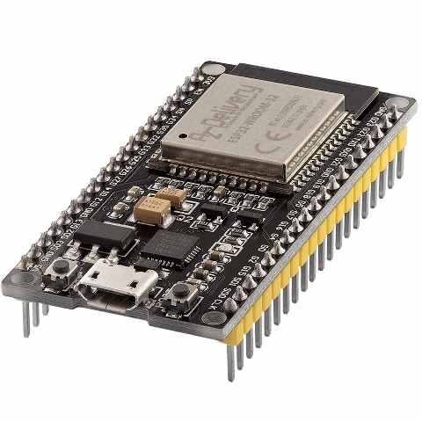

Figure .: Expressif Systems Processor (ESP) 32

### 3.2.2 Light Dependent Resistor (LDR)

An LDR, also called a photo resistor, photocell, or photoconductor, is a type of sensor that responds to changes in light by altering its resistance. When light falls on an LDR, its resistance changes. The intensity of the light reaching the LDR is inversely proportional to its resistance. The LDR is used to determine the turbidity levels of the water sample being tested. Since the water sample is clear initially, more light reaches the LDR, causing a decrease in its resistance. However, if the water sample contains coliform bacteria, after approximately 16 hours of incubation, it turns blue. As a result, the LDR receives less light, causing an increase in its resistance value.

Figure .: Light Dependent Resistor (LDR)

### 3.2.3 Relay

A relay is an electronic device that can be switched on or off when an external voltage (AC or DC) is applied across its control terminals. In this project, the relay is utilized to control the heating pad, which helps maintain the desired temperature range of 35-37℃ inside the incubator. The heating pad is connected to the relay, which is in turn connected to the ESP32. The ESP32 turns the relay on or off based on the temperature readings obtained from the DHT22 sensor, thereby regulating the temperature inside the incubator.

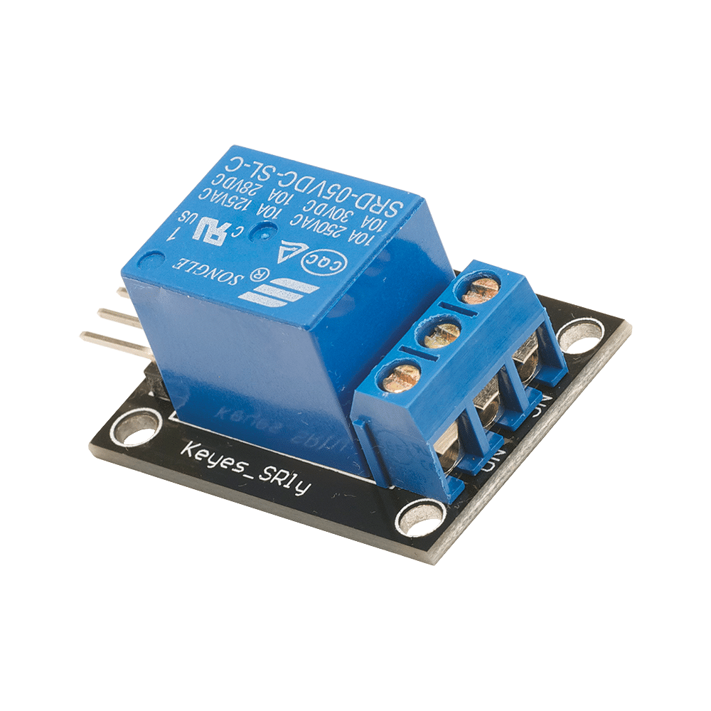

Figure .: Relay

### 3.2.4. DC-DC Converter

A DC-DC converter is an electronic device that can increase or decrease the voltage of a direct current power source to match a desired voltage level. In this project, a 5V buck converter is used to step down the voltage from the 220V AC to 12V DC power adapter to the 5V level needed to power the various components of the system.

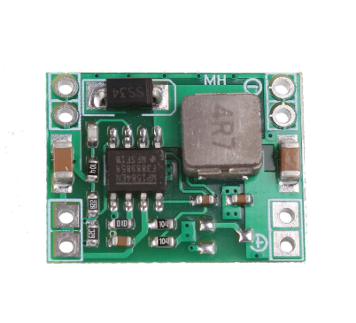

Figure .: DC-DC Buck Converter

### 3.2.5 Electrical Heating Element

The incubator utilizes an electrical heating pad as its source of heat, which is controlled by the relay. The relay is triggered on and off by the microcontroller, depending on the temperature readings from the DHT22 sensor. The heating pad plays a crucial role in maintaining the temperature range required for the coliform bacteria's optimal growth in the water samples, which is between 35-37℃.

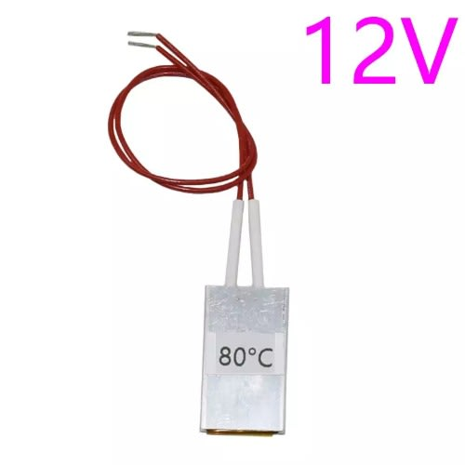

Figure .: Heating Source

### 3.2.6 LED Bulb

The LED bulb is used as the lighting source. It supplies the LDR with the sufficient light required to determine the turbidity levels of the water samples.

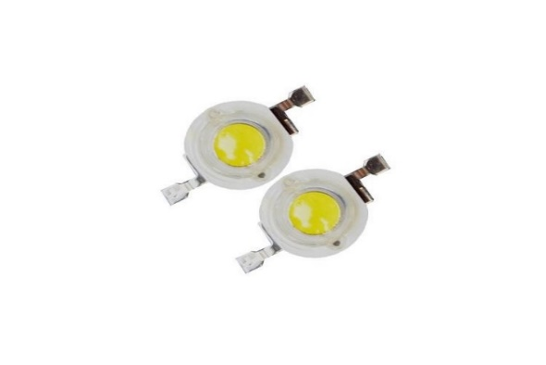

Figure .: LED Bulb

### 3.2.7 Potentiometer

A potentiometer is a type of variable resistor that can manually adjust the flow of current in a circuit. In this project, a potentiometer is used to control the brightness of the LED bulb. This is important because if the bulb is too bright, it could cause the LDR to become saturated and produce a constant or maximum output voltage, making it difficult to distinguish between transparent water and water with moderate turbidity. By adjusting the brightness with the potentiometer, the LDR can accurately detect the turbidity levels in the water samples.

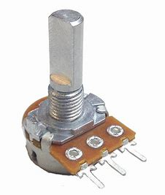

Figure .: Potentiometer

### 3.2.8 DHT22 Temperature and Humidity Sensor

The DHT22 sensor is utilized to obtain data on the temperature and humidity levels within the incubator. Its significance lies in ensuring that the temperature remains within the 35-37℃ range. The ESP32 is connected to this sensor for interfacing purposes.

Figure .: DHT 22

### **3.2.9 Liquid Crystal Display (LCD)**

For this project, a 20x4 (20 characters, 4 rows) LCD display is utilized to provide a user-friendly interface for monitoring real-time data readings from various sensors. The LCD display effectively shows temperature and humidity levels within the incubator, as well as the resistance readings of the Light Dependent Resistors. It is interfaced with the ESP32 microcontroller to display the data readings on the screen. The real-time data presented on the LCD enables users to monitor the progress of the incubation process and ensure the optimal conditions necessary for the growth of coliform bacteria.

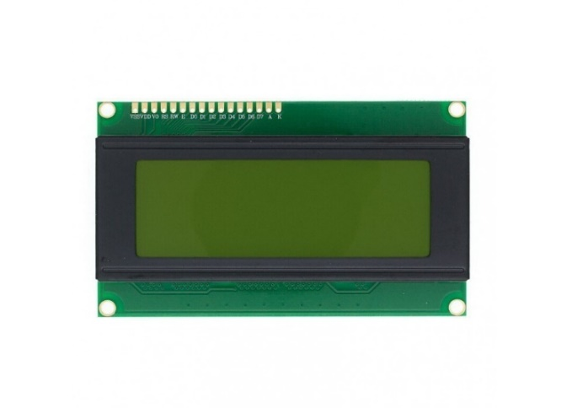

Figure .: Liquid Crystal Display

### 3.2.10 I2C Serial Interface Adapter Module

The LCD 20x4 display used in this project is connected to the ESP32 microcontroller using I2C communication protocol. This allows for a simpler and more efficient data transfer between the microcontroller and the LCD display. The I2C interface reduces the number of pins required for communication, making it easier to interface with other components in the project.

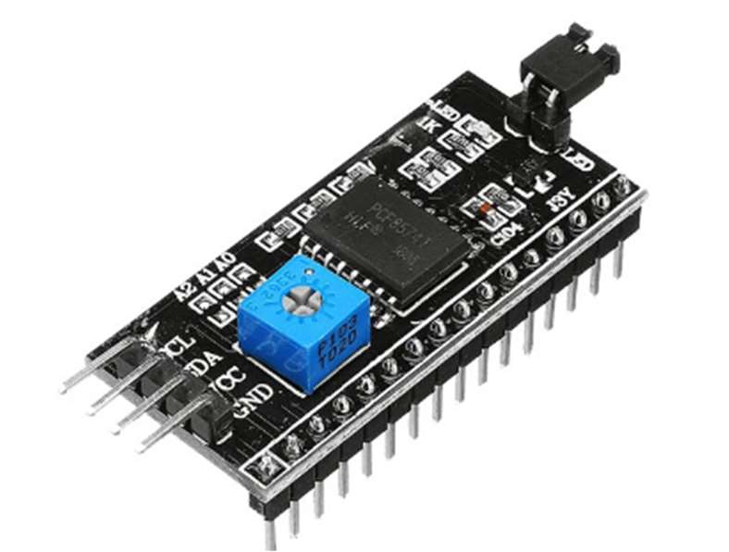

Figure .: I2C Serial Interface Adapter Module

### 3.2.11 Incubator

The incubator is an essential tool in detecting Coliform bacteria in water samples. Its importance lies in its ability to provide a controlled environment that promotes the growth of Coliform bacteria, necessary for their detection. The incubator ensures accurate and reliable results by maintaining constant temperature and humidity conditions, reducing the risk of false negatives. Additionally, the use of an incubator provides a standardized procedure for Coliform detection in water, allowing for consistent comparison of results across various samples and testing centers. In summary, the incubator is a critical component in the detection of Coliform in water, offering a dependable and consistent method for bacteria growth and detection.

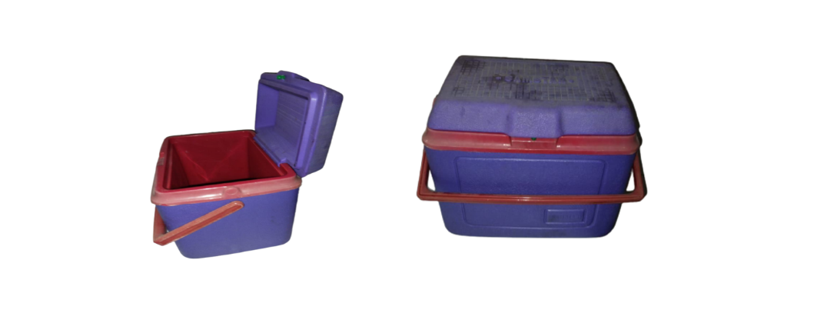

Figure .: Incubator

### 3.2.12 Beaker

The beakers are utilized to contain the water samples for testing. They are transparent and enable light to pass through the water sample to the LDR. Additionally, they have markings that allow for accurate measurement of the volume of water being tested in milliliters (ml).

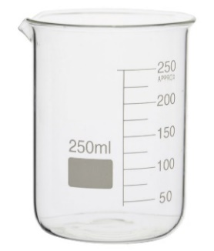

Figure .: Beaker

### 3.2.13 Water Detect Coliform Powder

The chemical being used for detecting coliform bacteria in water samples is a crucial component of our project. It is the only substance capable of detecting the presence of coliforms, which generate acids and gases through β-galactosidase enzyme activity at their optimal growth temperature of 35-to-37-degree Celsius(°C). The chemical works by breaking down a chromogenic or fluorogenic substrate, resulting in the production of color or fluorescence. Specifically, the powder changes the color of water samples from a clear and transparent appearance to a dark greenish hue, indicating the presence of coliforms. This color change is important for our project as it allows the Light Detecting Resistors to detect a decrease in light intensity when the water changes color, which indicates the presence of coliforms in the sample.

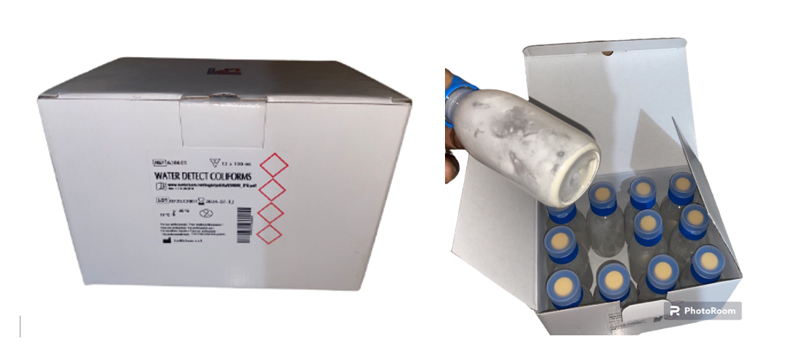

Figure .: Water Detect Coliform Powder

### 3.2.14 Power Supply Adapter

The incubator's components are powered by a power supply adapter, which includes a rectifying circuit that converts a 220V AC power supply to a 12V DC power supply suitable for our components.

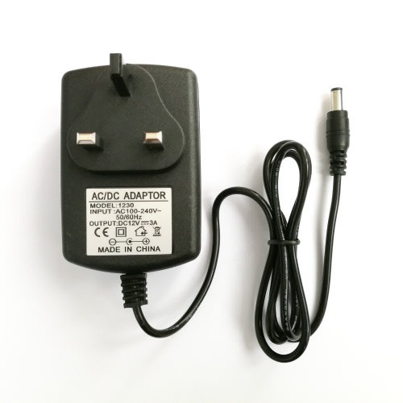

Figure .: Power Supply Adapter

## 3.3 Design specification

### 3.3.1 Systems Block Diagram

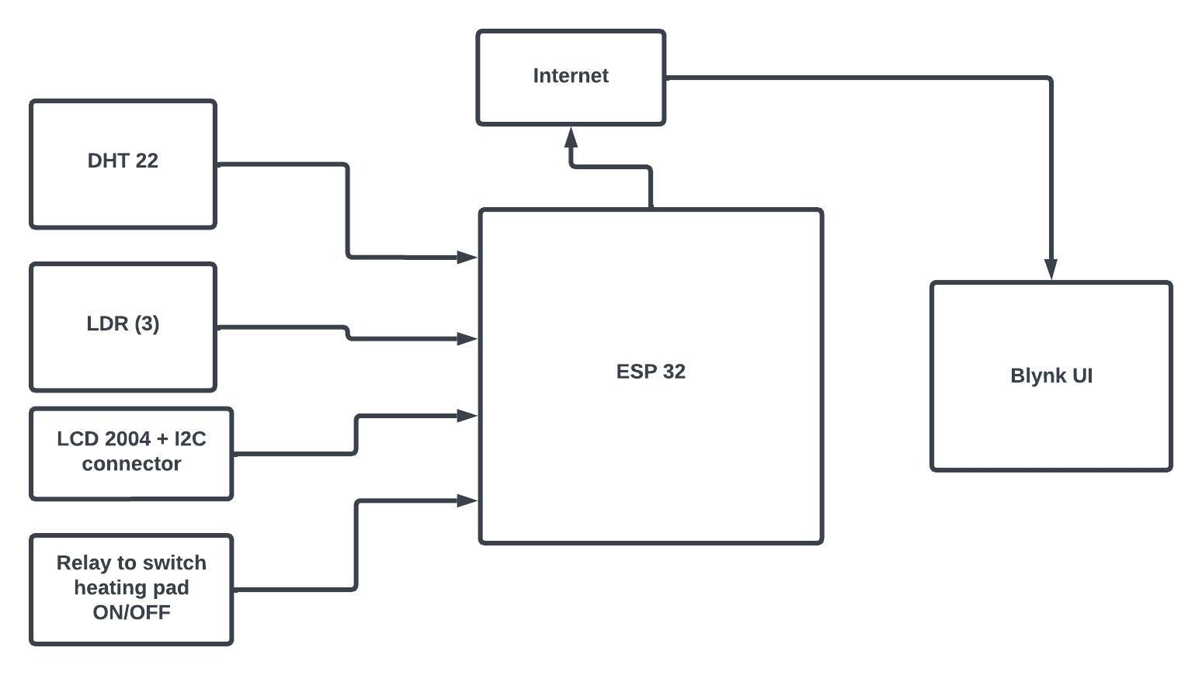

Figure .: Systems Block Diagram

### 3.3.2 Circuit Diagram

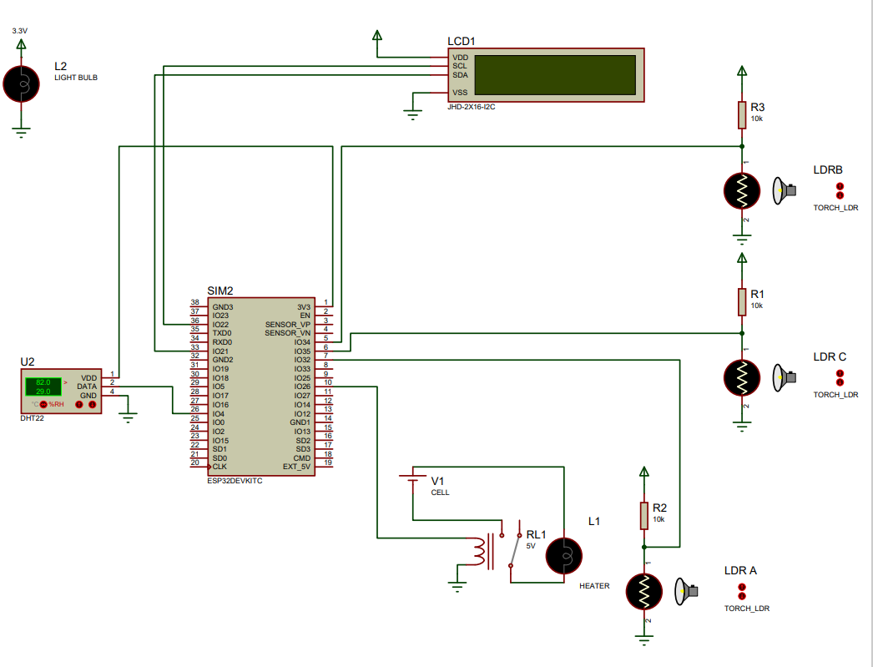

Figure .: Circuit Diagram

### 3.3.3 Systems Flowchart

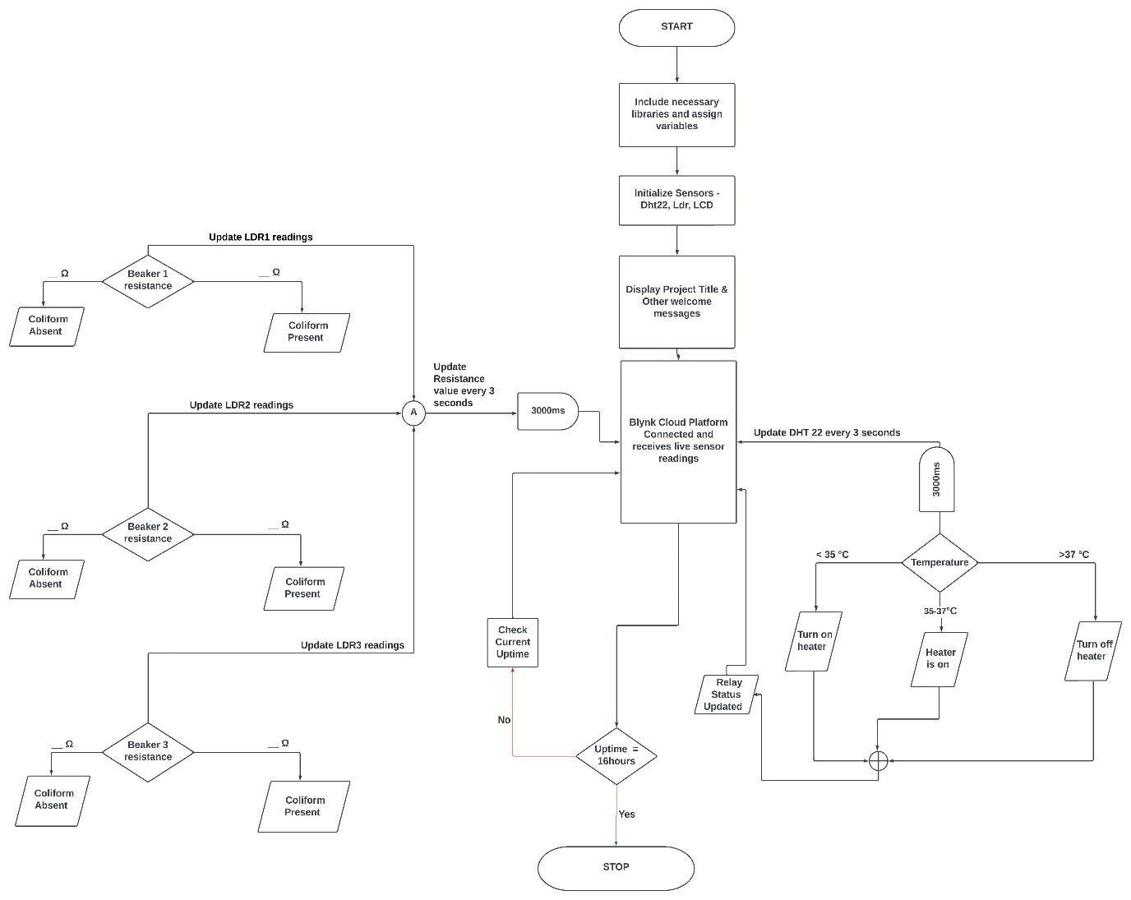

Figure .: Systems Flowchart

### 3.3.4 Electrical Calculations

**Heat transfer calculations**

In order to determine the appropriate rating for the heating element required for the incubator, it is important to consider the amount of heat energy needed to raise the temperature of both the water and air inside the incubator to the desired level. Using the specific heat capacity formula,

Where:

Q is the amount of energy (in joules)

m is the mass of water (in kilograms)

c is the specific heat capacity of water (in J/kg.k)

∆𝛉 is the change in temperature (in kelvin, K)

There are three beakers in total, each containing 100ml of water, making a total of 300ml. Converting 300ml to mass gives:

Density = Mass/Volume

Mass = Density x Volume

**Density of water = 1g/cm3 or 1g/ml, therefore, mass of water in incubator = 1g/ml x 300ml = 300g or 0.3kg**

The specific heat capacity of water is approximately **4190J/kg.k** Assuming the initial temperature of the water is room temperature **20°C (293k),** and we want to raise it to 37°C (310k), ΔT would be **17kelvin**. Therefore, the heat energy required to raise the temperature of 100ml of water is:

**Q = 0.1 kg * 4190J/kg.k * 17k = 7.123kJ**

Since there are three beakers, the total heat energy required to raise the temperature of all the water is:

**Q_total = 3 x 7.123kJ = 21.369kJ**

We also need to account for the heat energy required to raise the temperature of the air inside the incubator, in addition to that of the water. To calculate the amount of heat energy required to raise the temperature of a volume of air, the following equation can be used:

**Q = m x cp x ∆𝛉**

Where:

m = mass of air

**cp =** Specific heat capacity of air

∆𝛉 = change in temperature

The incubator has internal dimensions of 270mm x 140mm x 200mm. Therefore, volume of incubator = Length x Breadth x Height = 0.27m x 0.14m x 0.2m = **0.00756m3.** We need to raise the temperature inside the incubator from 20℃ (293k) to 35℃ (308k). ∆𝛉 will be **(308k – 293k = 15kelvin)**. The mass of air can be calculated using the density of air **(approximately 1.28 kg/m3)** and the volume of the incubator:

Density = Mass/Volume

Mass = Density x Volume

m = 1.28 kg/m3 * 0.00756m3 **= 0.009677kg**

The specific heat capacity of air is approximately **1005 J/kg·K**. Therefore, the heat energy required to raise the temperature of the air inside the incubator is:

**Q = 0.009677kg * 1005 J/kg·K * 15 = 145.88J**

The total heat energy required to raise the temperature of the water and air inside the incubator is:

**Qtotal = 21.369kJ + 145.88J = 21.514kJ**

To calculate the power rating required for the PTC heating element, we also need to consider the time it takes to raise the temperature. Let's assume we want to raise the temperature in 20 minutes or 1200 seconds. Therefore, the power rating required for the PTC heating element is gotten by using the formula **Q = pt**

**P = Qtotal / t** = 21.514kJ / 1200 **=** 17.9 watts **appx 18 watts**

Hence, a PTC element rated for about **18watts** will be sufficient to raise the ambient temperature in the incubator to 35-37℃ in 20 minutes. A lower rating heating element could alternatively be used, as the polystyrene foam used to pad the walls of the incubator will enhance insulation.

|  |  |  |
| --- | --- | --- |
| COMPONENT | VOLTAGE RATING | CURRENT DRAW |
| Espressif Systems Processor (ESP) 32 | 5v | 240mA |
| Relay | 5v | 160mA |
| Liquid Crystal Display (LCD) | 4.5v-5.5v | 120mA |
| Heating Element | 12v | 1670mA |
| LED Bulb | 3.4v | 350mA |

## 3.4 Description of Software Requirements

The programming of the entire system will be done using the Arduino C/C++ language on the Arduino Integrated Development Environment (IDE), followed by compilation and uploading to the microcontroller. The software required for this project is outlined below.

### 3.4.1 Arduino Integrated Development Environment (IDE)

The Arduino Integrated Development Environment (IDE), an open-source software, simplifies programming and uploading of code to the microcontroller board. It is compatible with various operating systems including Windows, Mac Operating System X, and Linux. The user interface was developed using Java and free and open-source tools like Lua Processing. Our project's Arduino board programming is written in C++, and the IDE software translates our readable human program codes into machine language. Before uploading to the microcontroller board, the IDE checks the source code for errors to ensure proper functionality.



Figure .: Arduino Integrated Development Environment (IDE)

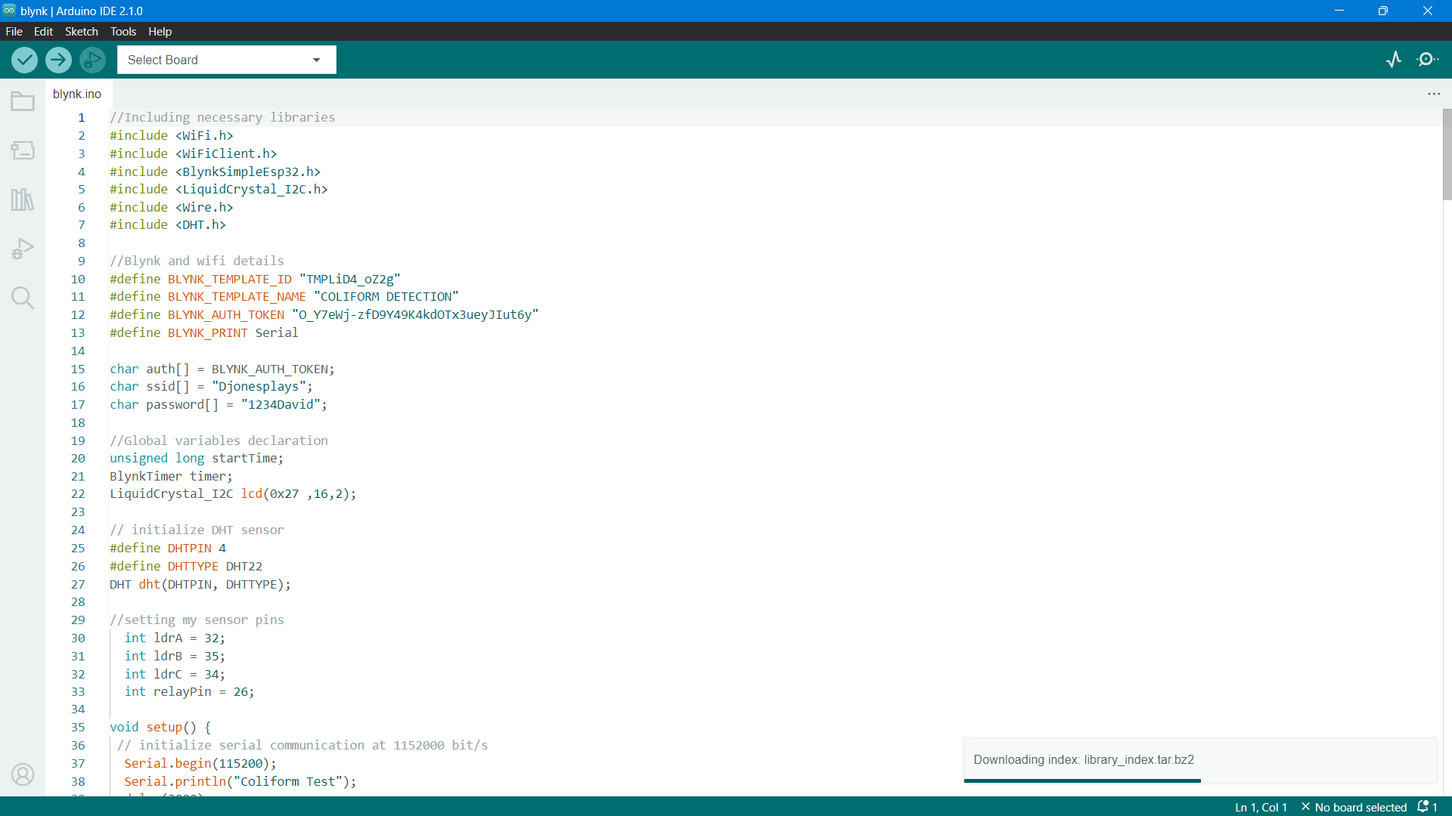

Figure .: Arduino Integrated Development Environment (IDE) Code Snippet

### 3.4.2 Blynk

Blynk is a versatile platform that enables users to create mobile applications that control and monitor devices over the internet. One of the key advantages of Blynk is its user-friendly interface, which makes it easy for users to monitor and control various IoT devices from their smartphones. In this particular project, Blynk plays a critical role in facilitating remote monitoring of the incubator's temperature and water quality parameters using a mobile device.

By integrating the ESP 32 with the Blynk platform, users can remotely monitor the temperature of the incubator and the water quality parameters in real-time. Blynk also allows users to set up alerts and notifications that can be sent to their smartphones if the temperature or water quality parameters fall outside the acceptable range. This feature ensures that users can respond quickly to any deviations from ideal conditions and prevent damage to the organisms being cultured in the incubator.

In summary, Blynk's user-friendly and convenient interface makes it an ideal platform for remotely monitoring and controlling the incubator's temperature and water quality parameters. By using Blynk in conjunction with the ESP 32, users can ensure that optimal conditions are maintained for the organisms being cultured in the incubator.

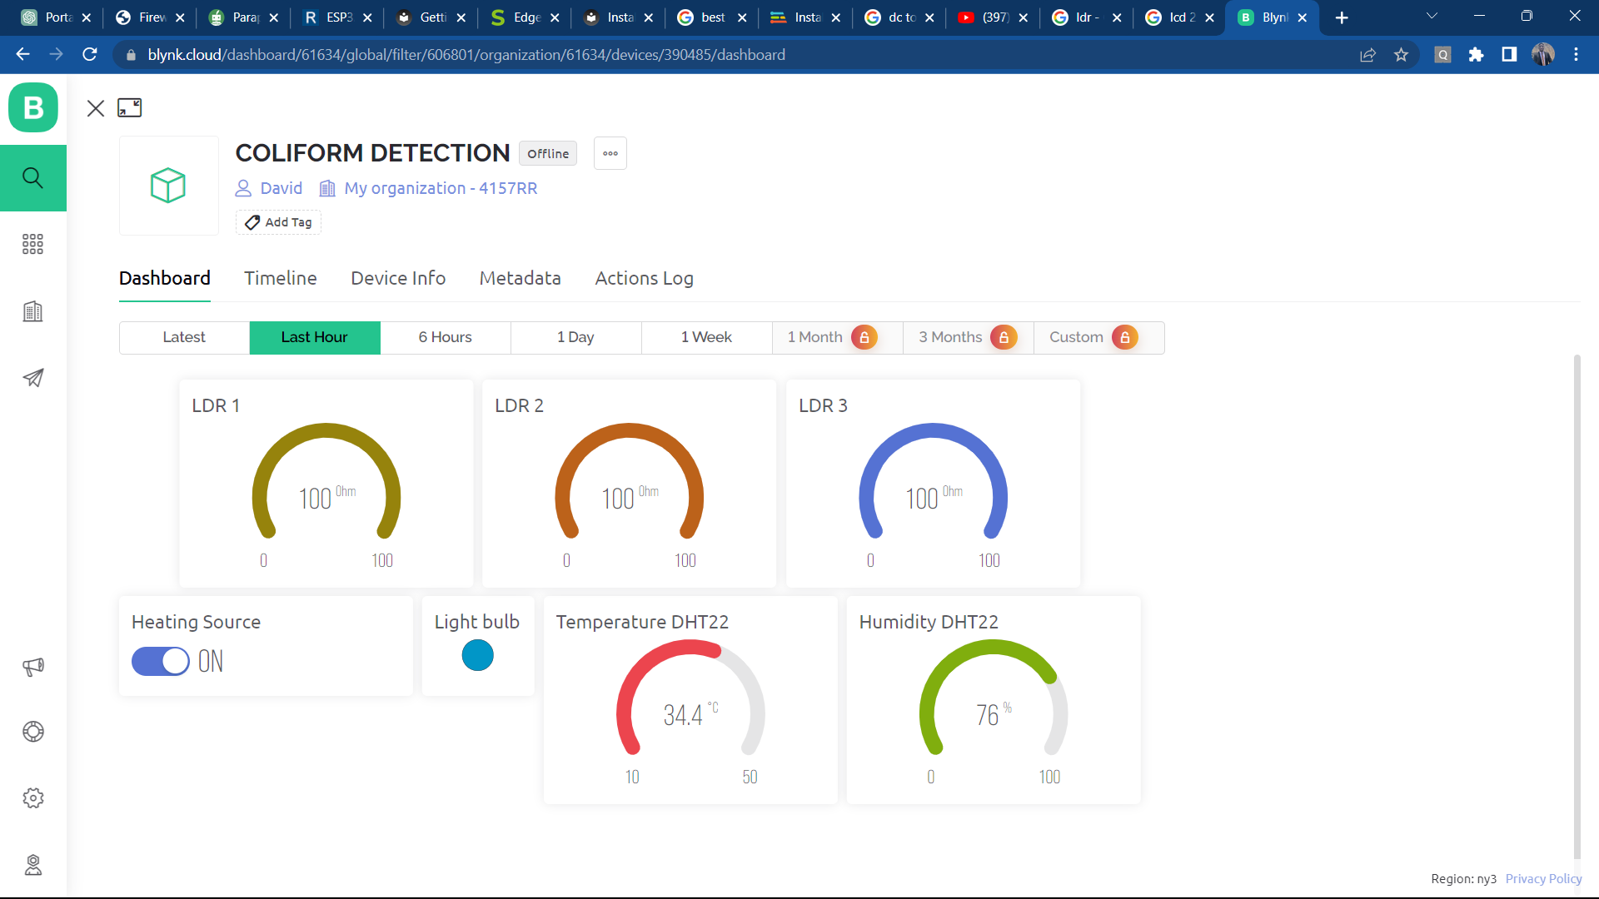

Figure .: Blynk Application

## 3.5 Conclusion

This chapter provides a comprehensive overview of the construction process of this project. It explains in detail the different components utilized, the circuitry, block diagrams, algorithms, and flowcharts employed. Moreover, it describes the architecture and techniques of the system, giving practical examples. The chapter also outlines the implementation procedures, including the proposed model and the development approach to be followed.

# REFERENCES

[1] A. Sarker, S. Dash, M. M. Hoque, S. Ahmed, and M. R. Shaheb, “Assessment of microbial quality of water in popular restaurants in Sylhet city of Bangladesh,” *Bangladesh Journal of Agricultural Research*, vol. 41, no. 1, pp. 115–125, 2016, doi: 10.3329/bjar.v41i1.27677.

[2] A. Schertenleib, J. Sigrist, M. N. D. Friedrich, C. Ebi, F. Hammes, and S. J. Marks, “Construction of a low-cost mobile incubator for field and laboratory use,” *JoVE (Journal of Visualized Experiments)*, no. 145, p. e58443, 2019.

[3] “Coliform Bacteria and Drinking Water,” no. April, 2011.

[4] P. Pal, “Detection of Coliforms in Drinking Water and its Effect on Human Health - A Review,” *International Letters of Natural Sciences*, vol. 17, pp. 122–131, 2014, doi: 10.18052/www.scipress.com/ilns.17.122.

[5] L. K. Bhardwaj and T. Jindal, “Evaluation of Coliform and Faecal Coliform Bacteria in the Lakes of Broknes and Grovnes Peninsula, East Antarctica,” *Nature Environment and Pollution Technology*, vol. 21, no. 5, pp. 2025–2034, 2022, doi: 10.46488/NEPT.2022.v21i05.002.

[6] P. Taylor, M. V Yates, S. R. Yates, and C. P. Gerba, “Critical Reviews in Environmental Control Modeling microbial fate in the subsurface environment,” no. March 2015, pp. 37–41, doi: 10.1080/10643388809388339.

[7] L. Niyoyitungiye, A. Giri, and M. Ndayisenga, “Assessment of Coliforms Bacteria Contamination in Lake Tanganyika as Bioindicators of Recreational and Drinking Water Quality,” *South Asian Journal of Research in Microbiology*, no. June, pp. 9–16, 2020, doi: 10.9734/sajrm/2020/v6i330150.

[8] F. M. Khan and R. Gupta, “Escherichia coli (e. coli) as an indicator of fecal contamination in groundwater: A review,” *Environmental Science and Engineering*, no. October, pp. 225–235, 2020, doi: 10.1007/978-3-030-45263-6_21.

[9] M. V. Yates and S. R. Yates, “Modeling microbial fate in the subsurface environment,” *Critical Reviews in Environmental Control*, vol. 17, no. 4, pp. 307–344, 1988, doi: 10.1080/10643388809388339.

[10] “EFFECT OF SEPTIC TANKS CONTAMINATION ON GROUNDWATER QUALITY AROUND ELEMENTARY SCHOOL IN IBADAN , OYO STATE NIGERIA,” no. March, 2023.

[11] S. Rafael, G. Lenn, and F. Yekeh, “Impact Of Constructing Septic Tanks in Close Proximity to Boreholes ( Ground Water ): The Case Of Kesselly Boulevard Community in Montserrado County , Original Research Paper Health Science IMPACT OF CONSTRUCTING SEPTIC TANKS IN CLOSE PROXIMITY TO,” no. June, 2021.

[12] V. O. Adetunji and I. A. Odetokun, “Groundwater contamination in Agbowo community , Ibadan Nigeria : Impact of septic tanks distances to wells,” vol. 7, no. 3, pp. 159–166, 2011.

[13] C. Y. Lin, M. H. Abdullah, B. Musta, A. Z. Aris, and S. M. Praveena, “Assessment of selected chemical and microbial parameters in groundwater of Pulau Tiga, Sabah, Malaysia,” *Sains Malays*, vol. 39, no. 3, pp. 337–345, 2010.

[14] “Guidelines for Canadian Drinking Water Quality: Guideline Technical Document – Enteric Viruses - Canada.ca.” https://www.canada.ca/en/health-canada/services/publications/healthy-living/guidelines-canadian-drinking-water-quality-guideline-technical-document-enteric-viruses.html (accessed Mar. 30, 2023).

[15] E. O. Longe and M. R. Balogun, “Groundwater quality assessment near a municipal landfill, Lagos, Nigeria,” *Research Journal of Applied Sciences, Engineering and Technology*, vol. 2, no. 1, pp. 39–44, 2010.

[16] K. Yusuf, “Groung Water in Lagos.Pdf.” [Online]. Available: http://www.docsdrive.com/pdfs/ansinet/jas/2007/1780-1784.pdf

[17] E. O. Orebiyi, J. A. Awomeso, O. A. Idowu, O. Martins, O. Oguntoke, and A. M. Taiwo, “Assessment of pollution hazards of shallow well water in Abeokuta and environs, southwest, Nigeria,” *Am J Environ Sci*, vol. 6, no. 1, pp. 50–56, 2010, doi: 10.3844/ajessp.2010.50.56.

[18] U. A. P. & Dr. O. a A. A, “Exploratory Survey of Geochemical Aspects of Underground Water in Ehime Mbano Area Se Nigeria,” *Global Journals of Research in Engineering, 11(4)*, vol. 11, no. 4, pp. 15–22, 2011.

[19] H. M. Solo-gabriele, M. A. Wolfert, T. R. Desmarais, and C. J. Palmer, “Sources of Escherichia coli in a Coastal Subtropical Environment,” vol. 66, no. 1, pp. 230–237, 2000.

[20] P. Harcourt, “The Effect of Septic Tank Locations on Borehole Water Quality in,” vol. 4, no. 5, 2014.

[21] “Management Plan to Reduce the Adverse Effects of Proximity of Dug Wells and Septic Tanks in Urban Area to Diminish Coliform Contamination,” vol. 7, no. 3, 2016.

[22] R. J. Perkins, “Septic tanks, lot size and pollution of water table aquifers,” *J Environ Health*, vol. 46, no. 6, pp. 298–304, 1984.

[23] M. V. Yates and S. R. Yates, “Septic Tank Setback Distances: A Way to Minimize Virus Contamination of Drinking Water,” *Groundwater*, vol. 27, no. 2. pp. 202–208, 1989. doi: 10.1111/j.1745-6584.1989.tb00441.x.

[24] “Environmental Impacts of Agricultural Modifications.” https://education.nationalgeographic.org/resource/environmental-impacts-agricultural-modifications/ (accessed Mar. 30, 2023).

[25] J. A. Entry and N. Farmer, “Movement of Coliform Bacteria and Nutrients in Ground Water Flowing through Basalt and Sand Aquifers,” *J Environ Qual*, vol. 30, no. 5, pp. 1533–1539, 2001, doi: 10.2134/jeq2001.3051533x.

[26] N. Sasakova *et al.*, “Pollution of Surface and Ground Water by Sources Related to Agricultural Activities,” vol. 2, no. July, 2018, doi: 10.3389/fsufs.2018.00042.

[27] “Agricultural Contaminants | U.S. Geological Survey.” https://www.usgs.gov/mission-areas/water-resources/science/agricultural-contaminants (accessed Mar. 30, 2023).

[28] “Poor Farming Practices & How They Affect Your Food – Thriving Yard.” https://thrivingyard.com/poor-farming-practices-how-they-affect-your-food/ (accessed Mar. 30, 2023).

[29] P. K. Weiskel, B. L. Howes, and G. R. Heufelder, “Coliform Contamination of a Coastal Embayment:  Sources and Transport Pathways,” *Environ Sci Technol*, vol. 30, no. 6, pp. 1872–1881, 1996, doi: 10.1021/ES950466V.

[30] A. O. Sojobi, “Evaluation of groundwater quality in a rural community in North Central of Nigeria,” *Environ Monit Assess*, vol. 188, no. 3, pp. 1–17, Mar. 2016, doi: 10.1007/S10661-016-5149-Y.

[31] P. Rajapaksha, A. Elbourne, S. Gangadoo, R. Brown, D. Cozzolino, and J. Chapman, “A review of methods for the detection of pathogenic microorganisms,” *Analyst*, vol. 144, no. 2, pp. 396–411, Jan. 2019, doi: 10.1039/C8AN01488D.

[32] S. N. Zulkifli, H. A. Rahim, and W.-J. Lau, “Detection of contaminants in water supply: A review on state-of-the-art monitoring technologies and their applications,” *Sens Actuators B Chem*, vol. 255, pp. 2657–2689, 2018.

[33] A. Verma, “Environmental Ethics : Need to Rethink Environmental Ethics : Need to Rethink,” no. July, pp. 1–4, 2020.

[34] M. Pal, Y. Ayele, A. Hadush, S. Panigrahi, and V. J. Jadhav, “Air & Water Borne Diseases Public Health Hazards Due to Unsafe Drinking Water,” vol. 7, no. 1, pp. 1–6, 2018, doi: 10.4172/2167-7719.1000138.

[35] P. Martins, N. O. Forstinus, and N. E. Ikechukwu, “Water and Waterborne Diseases : A Review Water and Waterborne Diseases : A Review,” no. January, 2016, doi: 10.9734/IJTDH/2016/21895.

[36] M. N. Iqbal and A. Ashraf, “Water Quality a Priority for Profitable Fish Farming,” *PSM Biological Research*, vol. 5, no. 2, pp. 92–94, 2020.

[37] A. S. Yusuff, W. John, and A. C. Oloruntoba, “Review on prevalence of waterborne diseases in Nigeria,” *J Adv Med Life Sci*, vol. 1, no. 2, pp. 1–3, 2014.

[38] “Drinking-water.” https://www.who.int/en/news-room/fact-sheets/detail/drinking-water (accessed Mar. 31, 2023).

[39] A. D. Lopez and C. D. Mathers, “Measuring the global burden of disease and epidemiological transitions: 2002–2030,” *Ann Trop Med Parasitol*, vol. 100, no. 5–6, pp. 481–499, 2006.

[40] W. J. W. Supply and S. M. Programme, *Progress on drinking water and sanitation: 2014 update*. World Health Organization, 2014.

[41] K. Khan *et al.*, “Prevalent fecal contamination in drinking water resources and potential health risks in Swat, Pakistan,” *Journal of Environmental Sciences*, pp. 1–12, 2017, doi: 10.1016/j.jes.2017.12.008.

[42] M. J. Allen, S. C. Edberg, J. L. Clancy, and S. E. Hrudey, “Drinking water microbial myths,” *Crit Rev Microbiol*, vol. 41, no. 3, pp. 366–373, 2015.

[43] R. Bain, R. Johnston, and T. Slaymaker, “Drinking water quality and the SDGs,” *NPJ Clean Water*, vol. 3, no. 1, pp. 7–9, 2020, doi: 10.1038/s41545-020-00085-z.

[44] P. Servais, J. Baudart, and A. Rompre, “Detection and enumeration of coliforms in drinking water : current methods and emerging approaches,” vol. 49, pp. 31–54, 2002.

[45] K. Gilbride, *Molecular Methods for the Detection of Waterborne Pathogens*. Elsevier, 2013. doi: 10.1016/B978-0-444-59543-0.00008-6.

[46] “Polymerase chain reaction - Wikipedia.” https://en.wikipedia.org/wiki/Polymerase_chain_reaction (accessed Mar. 31, 2023).

[47] “Detection of coliform bacteria in water by polymerase chain reaction and gene probes | Applied and Environmental Microbiology.” https://journals.asm.org/doi/full/10.1128/aem.56.2.307-314.1990 (accessed Mar. 31, 2023).

[48] S. F. Hussin and Z. Saari, “The Portable Incubator For E. coli and Coliform Bacterial Growth Using IoT,” *Advances in Computing and Intelligent System*, vol. 2, no. 1, 2020.

[49] M. Principle, T. Procedure, I. Results, and S. Life, “Water Detect Coliforms,” pp. 2–4, 2016.

[50] “Coliform bacteria - Wikipedia.” https://en.wikipedia.org/wiki/Coliform_bacteria (accessed Mar. 31, 2023).

[51] “The Internet of Things (IoT): An Overview - Internet Society.” https://www.internetsociety.org/resources/doc/2015/iot-overview/ (accessed Mar. 30, 2023).

[52] P. M. Pujar, H. H. Kenchannavar, R. M. Kulkarni, and U. P. Kulkarni, “Real ‑ time water quality monitoring through Internet of Things and ANOVA ‑ based analysis : a case study on river Krishna,” *Appl Water Sci*, 2020, doi: 10.1007/s13201-019-1111-9.

[53] “What is IoT (Internet of Things)? | Microsoft Azure.” https://azure.microsoft.com/en-us/resources/cloud-computing-dictionary/what-is-iot/ (accessed Mar. 30, 2023).

[54] M. J. Mudumbe and A. M. Abu-Mahfouz, “Smart water meter system for user-centric consumption measurement,” in *2015 IEEE 13th international conference on industrial informatics (INDIN)*, IEEE, 2015, pp. 993–998.

[55] K. Upadhyay, A. K. Yadav, and P. Gandhi, “A review of internet of things from Indian perspective,” *Engineering Vibration, Communication and Information Processing: ICoEVCI 2018, India*, pp. 621–632, 2019.

[56] R. Krishnamurthi, A. Kumar, D. Gopinathan, A. Nayyar, and B. Qureshi, “An overview of IoT sensor data processing, fusion, and analysis techniques,” *Sensors*, vol. 20, no. 21, p. 6076, 2020.

[57] S. Sanyal and P. Zhang, “Improving quality of data: IoT data aggregation using device to device communications,” *IEEE Access*, vol. 6, pp. 67830–67840, 2018.

[58] S. A. H. Almetwally, M. K. Hassan, and M. H. Mourad, “Real Time Internet of Things (IoT) Based Water Quality Management System,” *Procedia CIRP*, vol. 91, pp. 478–485, 2020, doi: 10.1016/j.procir.2020.03.107.

[59] M. Singh and S. Ahmed, “IoT based smart water management systems: A systematic review,” *Mater Today Proc*, vol. 46, pp. 5211–5218, 2021.

[60] “Data Analysis and Visualization in an IOT Dashboard.” https://psiborg.in/data-analysis-and-visualization-in-an-iot-dashboard/ (accessed Mar. 31, 2023).

[61] H. Khurshid *et al.*, “Bacterial prediction using internet of things (IoT) and machine learning,” *Environ Monit Assess*, vol. 194, no. 2, p. 133, 2022.

[62] U. Ahmed, R. Mumtaz, H. Anwar, S. Mumtaz, and A. M. Qamar, “Water quality monitoring: from conventional to emerging technologies,” *Water Supply*, vol. 20, no. 1, pp. 28–45, 2020.

[63] F. Jan, N. Min-Allah, and D. Düştegör, “Iot based smart water quality monitoring: Recent techniques, trends and challenges for domestic applications,” *Water (Basel)*, vol. 13, no. 13, p. 1729, 2021.

[64] N. S. Kamaruidzaman and S. N. Rahmat, “Water monitoring system embedded with internet of things (IoT) device: a review,” in *IOP conference series: Earth and environmental science*, IoP Publishing, 2020, p. 12068.

[65] B. T. Heligman *et al.*, “The design and usage of a portable incubator for inexpensive in-field water analysis,” *Journal of Humanitarian Engineering*, vol. 6, no. 2, 2018.

[66] A. Schertenleib, J. Sigrist, M. N. D. Friedrich, C. Ebi, F. Hammes, and S. J. Marks, “Construction of a Low-cost Mobile Incubator for Field and Laboratory Use Construction of a Low-cost Mobile Incubator for Field and Laboratory Use,” no. March, 2019, doi: 10.3791/58443.

[67] S. N. Ibrahim, A. L. Asnawi, N. Abdul Malik, N. F. Mohd Azmin, A. Z. Jusoh, and F. N. Mohd Isa, “Web based Water Turbidity Monitoring and Automated Filtration System: IoT Application in Water Management.,” *International Journal of Electrical & Computer Engineering (2088-8708)*, vol. 8, no. 4, 2018.

[68] S. Manoharan, G. Sathiyaraj, K. Thiruvenkadakrishnan, G. V Vetriselvan, and P. Kishor, “Water quality analyzer using IoT,” *Int. J. Innov. Technol. Explor. Eng*, vol. 8, pp. 34–37, 2019.